Navisworks Clash Data Export to SQLite

To install place the clash_sqlite_export.dll file in the following location on your PC.

Installation Location - C:\Program Files\Autodesk\Navisworks Manage 2021\Plugins\clash_sqlite_export

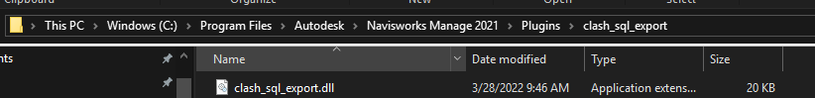

This plugin also requires the clashes_to_sql exe file to be fully functional. Refer to the Clashes to SQL instruction document for more information.

Once it is installed you will see a new button under the “Tool add-ins 1” tab called “Export Clashes to SQL”.

Image 1:

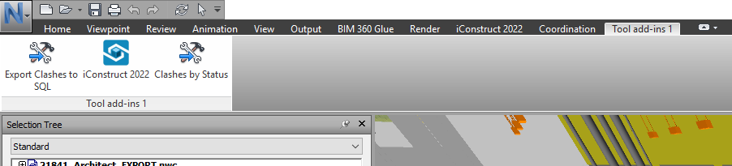

Running the Plugin

1. Run your clashes test using the standard IPS clash tests found in the following folder

\\ipsfs01\Q\Design\Navisworks

Import the “Clash Test List.xml” file into your Navisworks NWF file.

1. Once you have reviewed the test results, organized them, and assigned them to users you are ready to export the results.
2. Select the “Export Clashes to SQL” plugin. You will be prompted to select a save location for the xml data files. Browse to your project on the P drive find the folder shown within the project (see Image 2). Create a folder with today’s date in the following format YYYY.MM.DD. Select this new folder as your destination for the xml files and click “OK”.

Image 2:

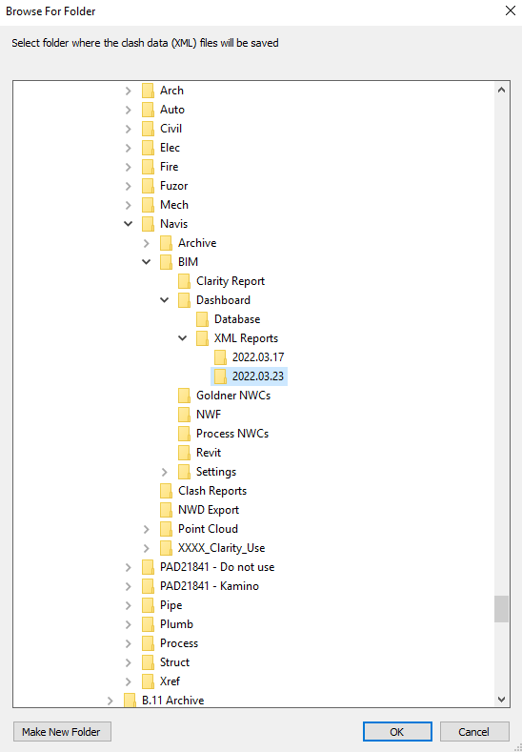

1. Next you will be prompted to write the clashes to the database.

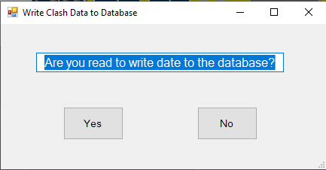

1. If you select “NO” nothing will be written to the database. You can manually run the “clashes_to_sql_v1.0.0.exe” file at a later time to enter the clashes in to the data base. The following message will appear.

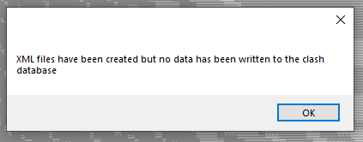

If you select “Yes” the plugin will launch the “clashes_to_sql_v1.0.0.exe” file. See those instructions for the next steps. ( Start with Step 2 in those Instructions)